CAMP PEP 2017
July 10th – August 4th
Four - one week sessions at PEP
1200 South Broad Street, Philadelphia, PA 19146
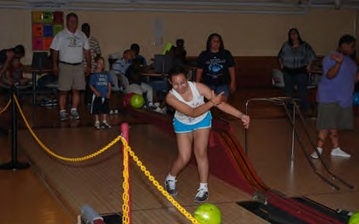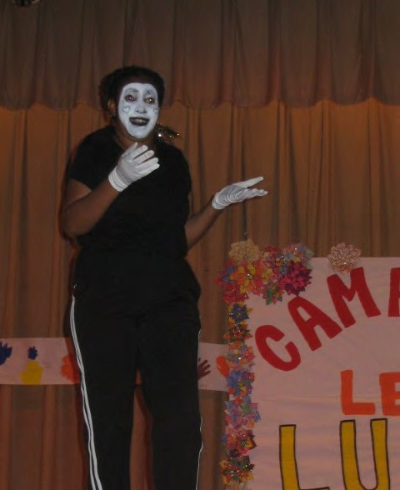

Arts, Crafts, Music, Sports, Swimming, Field Trips, Museums, Theaters Fun Packed Days
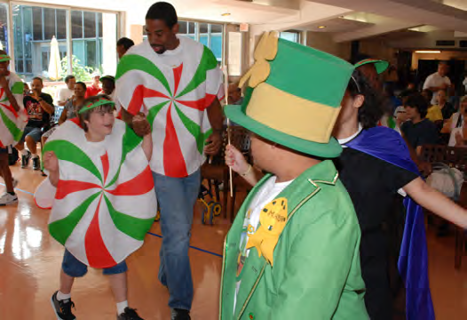

Lunch - Snacks – Trips - T-Shirt included
$300 per week
First time Camper Scholarships - Waiver Funding - FDSS Funding Available
Applications on line at: http://bit.ly/CampPEP2017Application
Email: Camppep@pepservices.org

Call 215-389-4006 for more information or Registration Information.
Don’t delay limited space available

Camp PEP Scholarship Program

Through the generosity of a Friend of PEP we are happy to offer a limited number of scholarships to new Camp PEP Campers each year.

The scholarships are intended to introduce new campers with special needs to Camp PEP

The scholarship is for one week at Camp PEP it can also be used to extend a new campers experience by a week of paid registration. Pay for one two or three weeks and get an additional week at no cost.

The scholarships are for new campers and there are three scholarships available. If more than 3 new campers register for camp the scholarships will be awarded through a lottery of all eligible campers.

Application process is simple; complete a camp application by June 1st indicate on the cover page that this is a new camper application, if awarded a scholarship you will be notified by phone and mail the second week of June.

Scholarship deadline for camp applications is Thursday, June 1.

